**7th July 2024**

You are summoned to a meeting of Doddington and District Parish Council to be held at Hankelow Methodist Hall on 15th July 2024 at 7.30 for the transaction of the business below.

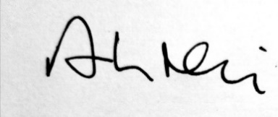

Arthur Neil

**Clerk to the Council**

**7th July 2024**

**Parish Council Meeting**

**Hankelow Methodist Chapel**

**Monday 15th July 2024 , 7.30**

**AGENDA**

1. Apologies for absence
2. Declarations of Interest
3. Minutes of the May Meeting
4. Community Engagement – opportunity for members of the public to speak
5. Finance Report.
6. Spending approvals  
   Clerk -Salary £244.20  
   ThenMedia £144.00 – agreed to pay in six monthly instalments  
   Zurich Insurance £446.86
7. Finance Reports
8. Community Infrastructure Levy – suggestions for spend.
9. Facebook update and newsletter
10. Planning Applications

***24/2172N: Checkley Lodge, Checkley Lane (Last Comments 17.07.2024)***

***24/1297N: Doddington Estate (Site 1) (Last Comments 10.07.2024) – briefing***

24/1695N: Yew Tree Cottage, Yew Tree Lane (Last Comments 26.06.2024) – briefing

24/1246N: Doddington Park House (Last Comments 03.07.2024) – briefing

***24/1221N: Doddington Park Farm (Retrospective), (Last Comments 10.07.2024)***

1. Borough Councillor’s Report
2. Ward Members’ Reports