E: [Clerk@doddingtondistrict.org.uk](mailto:Clerk@doddingtondistrict.org.uk) [www.doddingtondistrict.org.uk](http://www.doddingtondistrict.org.uk)

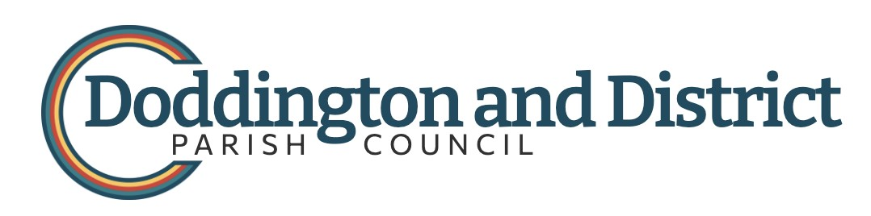

**Annual Parish Meeting**

**Monday 20th May 7.00 pm**

**Hankelow Methodist Hall**

Any elector in the parish may attend and speak on any matter of interest to the parish.

Followed by the **Annual Parish Council Meeting**

To which members of the public are invited and may speak by invitation

Immediately followed by

**Ordinary Business**

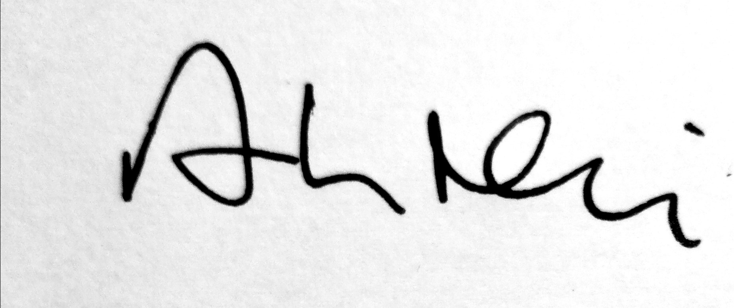

**Arthur Neil**

**Clerk to the Council**

Arthur Neil

**Clerk to the Council**

**13th May 2024**

**13th May 2024**

You are summoned to a meeting of Doddington and District Parish Council to be held at Hankelow Methodist Hall on 20th May 2024 immediately following the Annual Parish Meeting for the transaction of the business below.

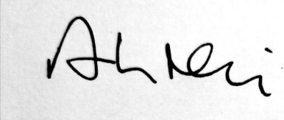

Arthur Neil

**Clerk to the Council**

**13th May 2024**

**Parish Council Meeting**

**Hankelow Methodist Chapel**

**Monday 20th May 2024 , 7.30**

**AGENDA**

1. Apologies for absence
2. Declarations of Interest
3. Minutes of the March Meeting
4. Community Engagement – opportunity for members of the public t\o speak
5. Finance Report.
6. Spending approvals  
   Clerk -Salary £244.20  
   ThenMedia £48.00  
   Hankelow Methodists rent £60.00
7. To approve accounts and AGAR for 2023-2024
8. Community Infrastructure Levy – suggestions for spend.
9. HS2 update
10. Facebook update and newsletter
11. Planning Applications
12. Borough Councillor’s Report
13. Ward Members’ Reports